Fixed Point Binary Numbers
Introduction
So far we have seen how the place values of a byte, (from right to left), increase in the following manner:
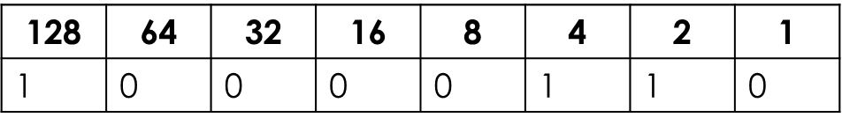

This binary number therefore represents 134.
But this doesn’t have to be the case, particularly in the case of a byte representing a decimal number.
We will now look at how decimal numbers can be represented in binary.

Fixed Point Numbers
To represent decimal values, the decimal point can be fixed into a given position with the ‘usual’ place values to the left (representing the whole number part) but with new ‘fractional’ place values for the fractional part of the number.
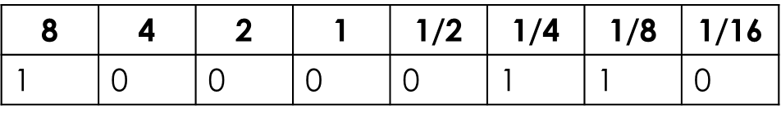

This binary number therefore represents the denary number 8.375. This is because after the decimal point, the binary number value is 1/4 + 1/8 = 0.375, which is added to the whole number part.
It is important at this point to recognise that representing decimals in binary is far less accurate than in denary. For example, there is no way to represent 0.2, we can only get a close approximation by adding the appropriate fractional parts together.

Converting Decimal to Fixed Point Binary
Converting from denary to decimal is actually quite an easy process.
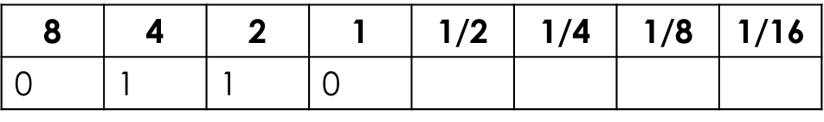
We should be happy with the idea of converting the whole number part. For example if it was 6.8125, we would put a 1 under each place value needed to total 6 (e.g. 6 is made from a 4 and a 2):

To convert the rest (0.8125) we can use the same principal…let’s see how...
Converting Decimal to Fixed Point Binary
Using the subtraction method we can keep subtracting the place values until the fraction is formed.
Each time a place value can be subtracted, we place a one in that column and if it cant be subtracted, we place a zero.
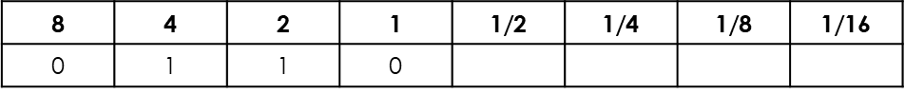

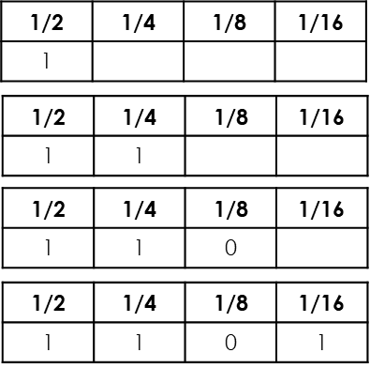
0.8125 – 0.5 = 0.3125 (success!)

0.3125 – 0.25 = 0.0625 (success!)

0.0625 – 0.125 = Can’t be done!

0.0625 – 0.0625 = 0 (success!)

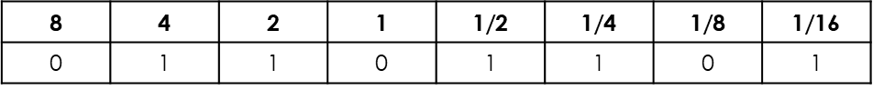

Fixed Point Numbers – A compromise
One issue with representing binary numbers this way is that you have to compromise range against accuracy.
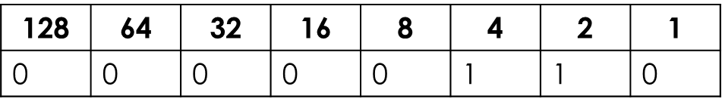
Using all the bits as integer values, gives you a range of 0-255 integers, but no fractional values can be given to increase accuracy of the number being represented.

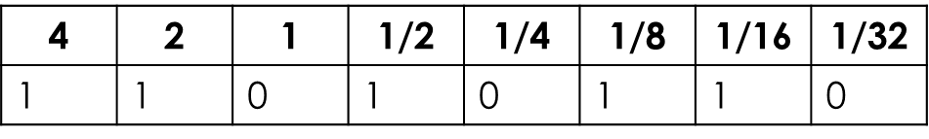
On the other hand, using 3 bits for the integer part will provide only a range of 0-7 integers but will enable a fair degree of accuracy with more bits given to the fractional part of the number.

Questions
‘General Understanding’ Questions
- Explain, using examples, how a decimal number can be represented as a fixed point binary number.
- Convert the following fixed point binary numbers into decimal (in each case 4 bits are given to the integer part and 4 bits to the fractional part of the number):
11001010
01111011
11111111
00010001
- Convert the following decimal values into fixed point binary (in each answer provide 4 bits to the integer part and 4 bits to the fractional part of the number):
3.25
5.5
7.1875
10.375
- Explain the issues of using this method to represent fractional values (think range and accuracy)

____________________________________________________________________________________________________________________________________________________________________________________________________________________________________________________________________________________________________________________________________________________________________________________________________________________________________________________________________________________________________________________________________________________________________________________________________________________________________________________________________________________________________________________________________________________________________________________________________________________________________________________________________________________________________________________________________________________________________________________________________________________________________________________________________________________________________________________________________________________________________________________________________________________________________________________________________________________________________________________________________________________________________________________________________________________________________________________________________________________________________________________________________________

Keywords / Key Terms:

Checklist:
Date and title, clearly presented
Spelling & grammar checked
Question numbers in the margin
Handwriting neat & legible
Punctuation / Capital letters

____________________________________________________________________________________________________________________________________________________________________________________________________________________________________________________________________________________________________________________________________________________________________________________________________________________________________________________________________________________________________________________________________________________________________________________________________________________________________________________________________________________________________________________________________________________________________________________________________________________________________________________________________________________________________________________________________________________________________________________________________________________________________________________________________________________________________________________________________________________________________________________________________________________________________________________________________________________________________________________________________________________________________________________________________________________________________________________________________________________________________________________________________________

- State/Identify/Give/Name: Simply label a diagram, fill out a table or write a few words
- Describe: Describing is ‘saying what you see’ (E.G.: A computer will have a CPU, Primary and Secondary storage etc)
- Explain: Explaining is ‘saying WHY/HOW something is like that’. (E.G.: A computer will have a CPU so that it can process all of the data the computer needs to perform a range of tasks. Primary and Secondary storage is needed because…)
- Discuss: Discussing is ‘looking at two sides of an issue, weighing up the two views and giving a conclusion’. Often these require a mini essay answer. (E.G.: New technology could be seen as being bad for the environment because…, but on the other hand, new technology has led to… In conclusion I believe that…)
- Describe/Explain/Discuss using examples: Finally, if you are asked to give examples in any of these types of questions – YOU MUST GIVE EXAMPLES!

Stick answer sheet here

Reflections:

On / Above / Below
Progress:

Grade:

%
Percentage:

/
Score:

My answers effectively incorporated technical terminology.
My responses were well structured / organised.
I demonstrated a good level of understanding.
I responded to the command words effectively.
My work was well presented / legible.
My answers were detailed / were written in depth.
What Went Well?:

My revision strategy was effective as I showed depth of understanding in my answers.
My answers contained enough points / examples / explanations to achieve the marks available.
Even Better If…:

I must better organise my answers to improve its clarity.
I must incorporate key terminology into my answers.
I must take greater care over my work / write neatly.
My answers need more detail / greater depth.
I must respond correctly to the command words.
My answers need to be more accurate / specific.
I need to improve my revision strategy, as I did not demonstrate a depth of understanding in my answers.
My answers didn’t contain enough points / examples / explanations to achieve the marks available.
Further thoughts:

________________________________________________________________________________________________________________________________________________________________________________________________________________________________________________________________________________________________________

