Introduction to Python – Lesson 1
Introduction
Python is a very powerful programming language used by many huge and important companies. For example, Google uses python for parts of some its apps and also python is used for some of the internal scripts for its search engine. NASA has used Python in a number of its application systems. Yahoo uses Python when it comes to maintaining its discussion groups and YouTube uses Python for some of its features too!

Learning to program like the professionals!
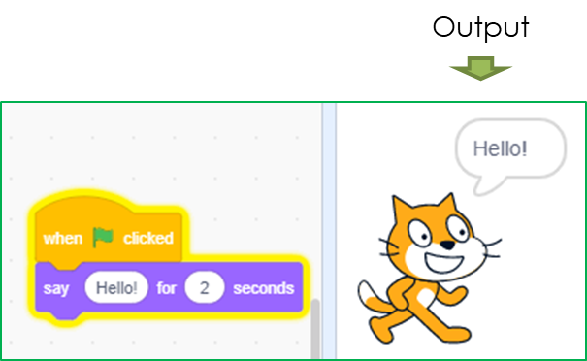
If you have previously programmed in Scratch, there is good news because programming in Python is just like programming in Scratch, it’s just that you have to write the code yourself instead of using the coloured ‘building blocks’.

Programming Outputs
You may remember that to program outputs in Scratch, we use the ‘Say’ block.
In python, we can achieve the same result by using a print() statement.
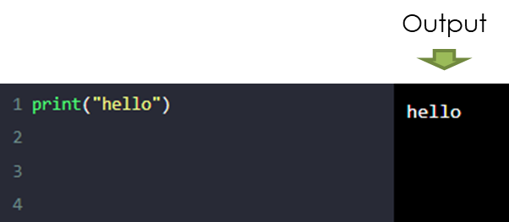
The print() statement simply works by outputting the contents of its brackets to the display.
If we wish it to print some text, the text must be surrounded by quotes, as shown in the example image.

Programming Inputs & Storing Inputs
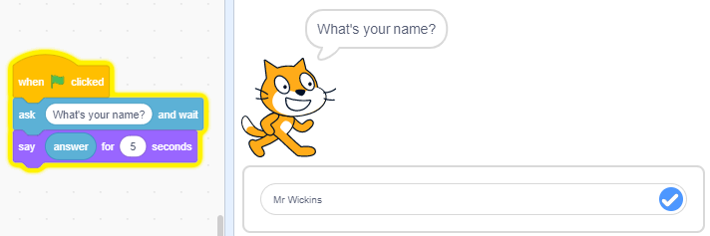
In Scratch, the ‘Ask’ block would allow our sprite to ask the user to enter an input.
The ‘answer’ variable would store the input.
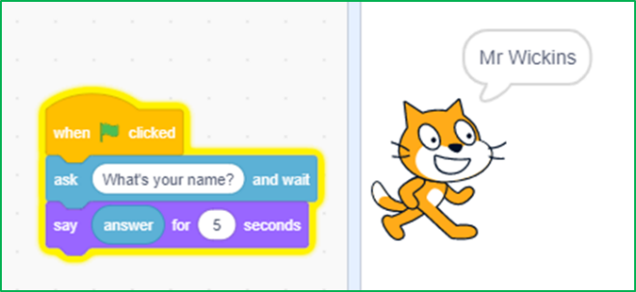
And we could use the answer variable with a ‘Say’ block to output the inputted value.
In python, we can achieve the same result by using a input() statement and assigning it to a variable.
Let’s have a look at what that means!
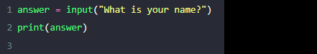
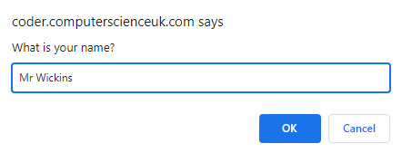
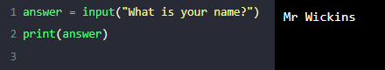
In Python, the ‘input’ statement would allow our program to ask the user to enter an input.
Output

The ‘answer’ variable, which has been assigned to the input statement, would store the input.

And we could use the answer variable with a ‘print’ statement to output the inputted value.

Understanding the major difference between a print() and an input() statement
When a print() statement is run by the computer, it will cause the computer to display a message, and then the program will immediately continue to run the next line of code.
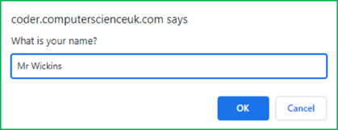
When an input() statement is run by the computer, it will also cause the computer to display a message, however the program will pause and wait for a user input!
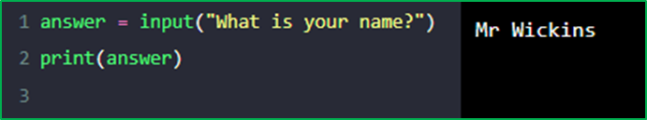
So, it needs to have a variable assigned to it if we want to store what the user types in.
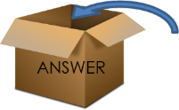
What the user types in (e.g. their name) will be stored in the assigned variable.

So hopefully the above has given you some understanding of how we can program outputs and inputs in Python.
However, the most effective way of truly understanding how programming works, is to get stuck into some practical programming tasks.
Below are a series of tasks designed to guide you through the basics of programming in the python programming language.

PRIMM TASKS
1: Predict
Code
Predictions | What do you think the code will do?
 | Write the program’s output exactly as you think it will appear.
 | >>>

2: Run
Now type in the code and run the program.
Show a screen shot of the actual output below.
Was it the same as your prediction? | Yes | No
Were there differences? If so, show or describe these below.

3: Investigate
- What happens if you remove the quotes? Why?
- What happens if you change the word ‘there’ to ‘you’? Why?
- What happens if you make the ‘p’ of print a capital ‘P’? Why?

4: Modify
Study this code: | 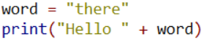
Modify your code to match the example.  Explain what the code is doing. | Screenshot /Explanation

5: Make
Create a program in python for each point below and add a screenshot of your code in the boxes provided:
- Create a program which prints your name to the screen

- Create a program which prints a message of your choice to the screen

.--.
.----' '--.
'-()-------()-'

- Create a program to output this car to the screen

- Create a program to output a design of your choice to the screen

